Go to Edamam Developer Portal: <https://developer.edamam.com/>

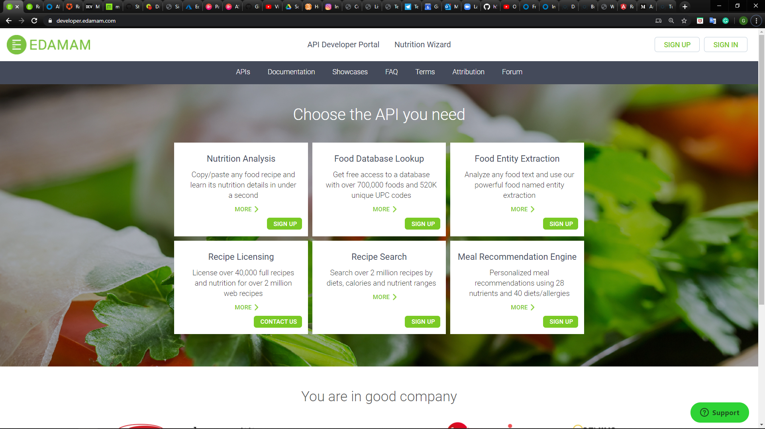

Click on “Sign Up” at Recipe Search

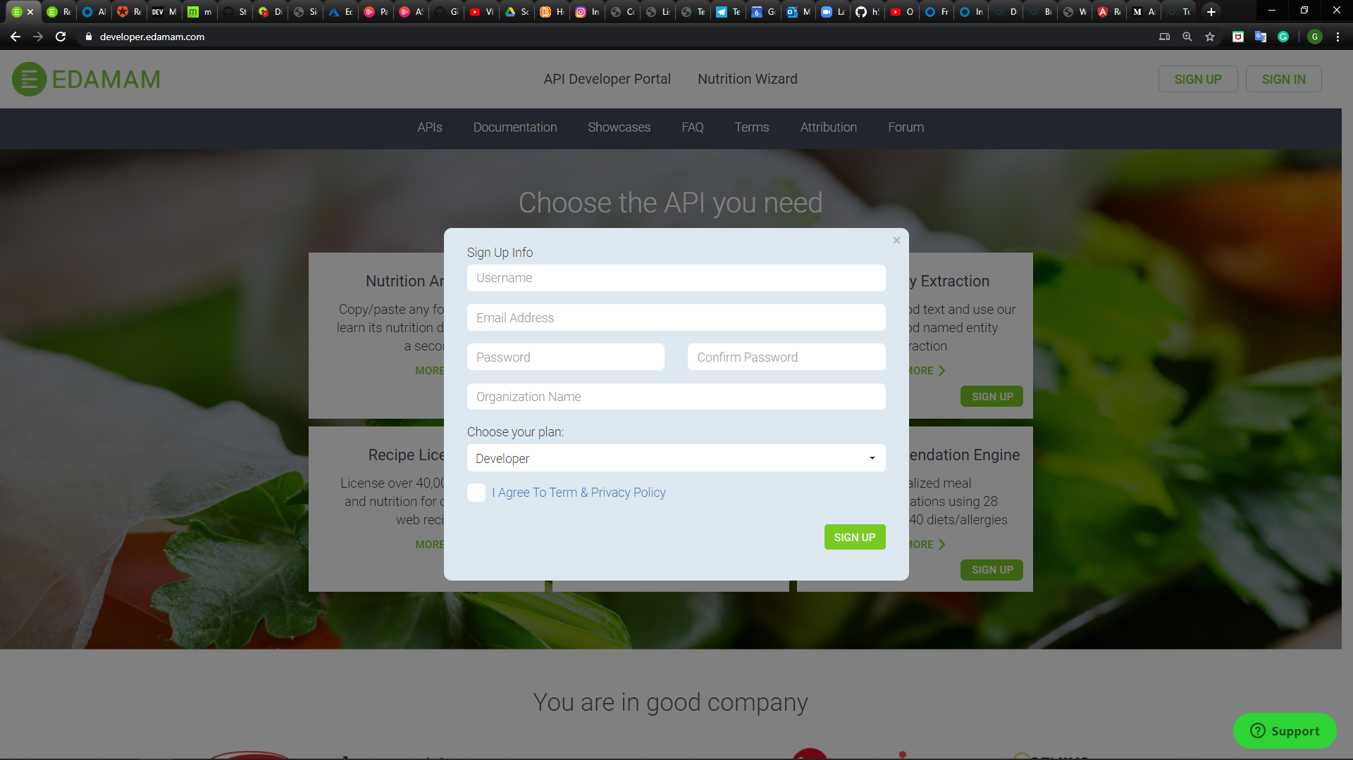

Fill out the form with the required information

Then sign into your account and Click on “Get an API key now!”

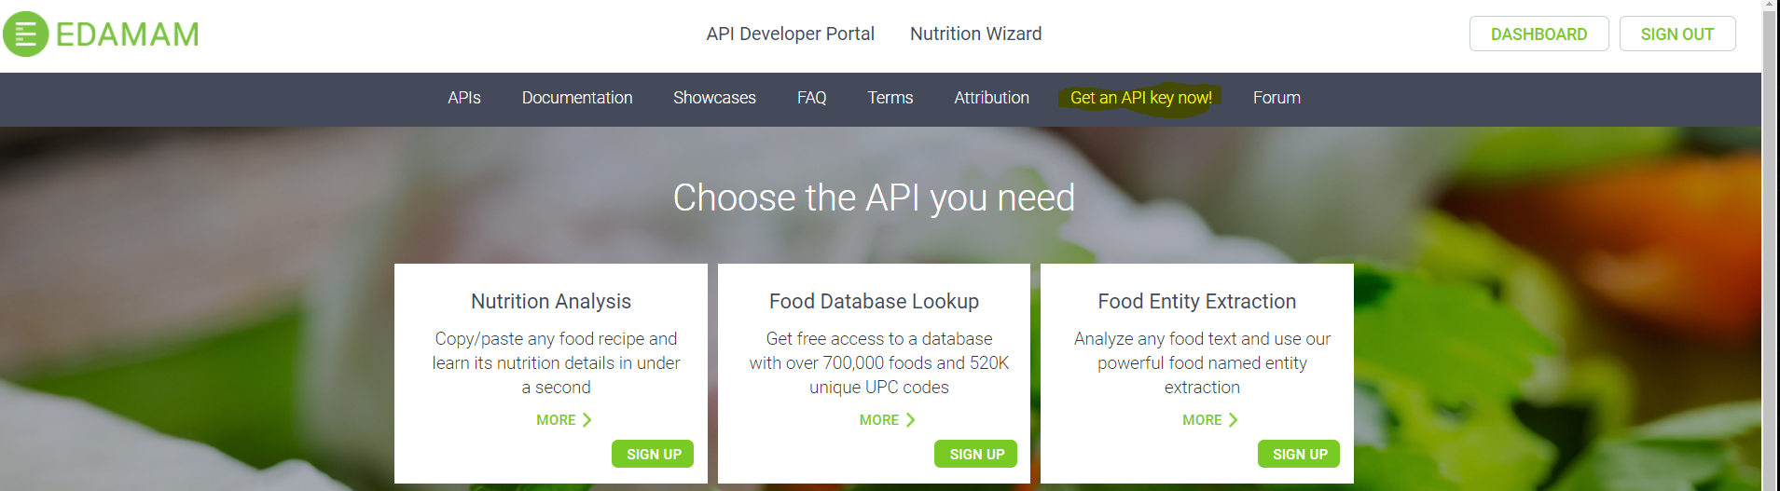

You Applications will open

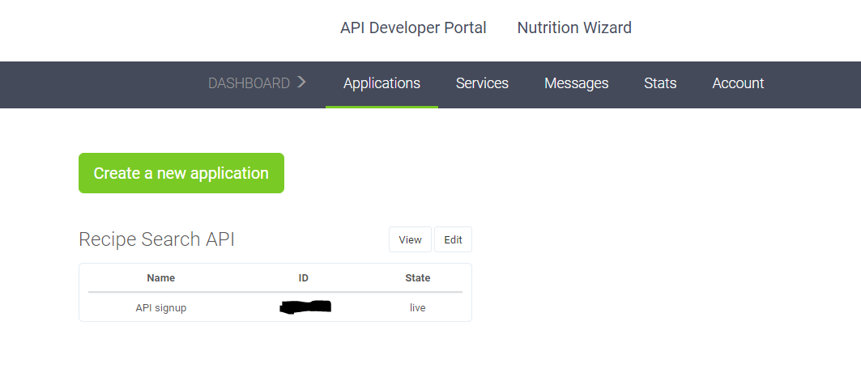

In “Recipe Search API”, click the button “View” to get more information

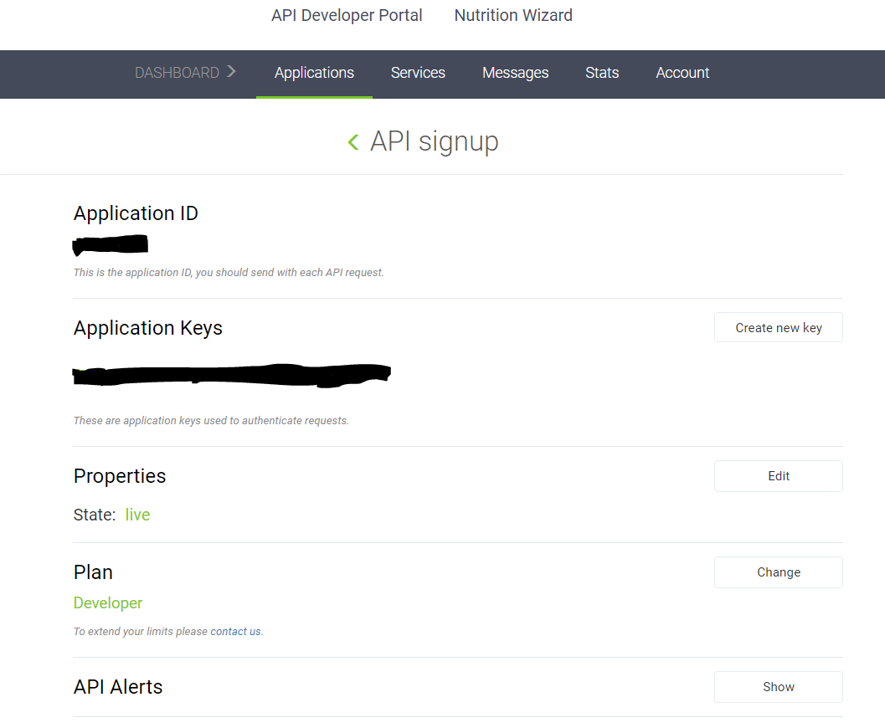

Once you have the Application ID and Application Keys, copy and paste into each of the respective fields into the config file in RecipeBook.

RecipeBook – located at “{Your PC path}\recipebook\RecipeBook\config\config.json”

